Must have Ver. 1.31 software. Only applies to groover on 7EX / ES-Versa drill assembly.

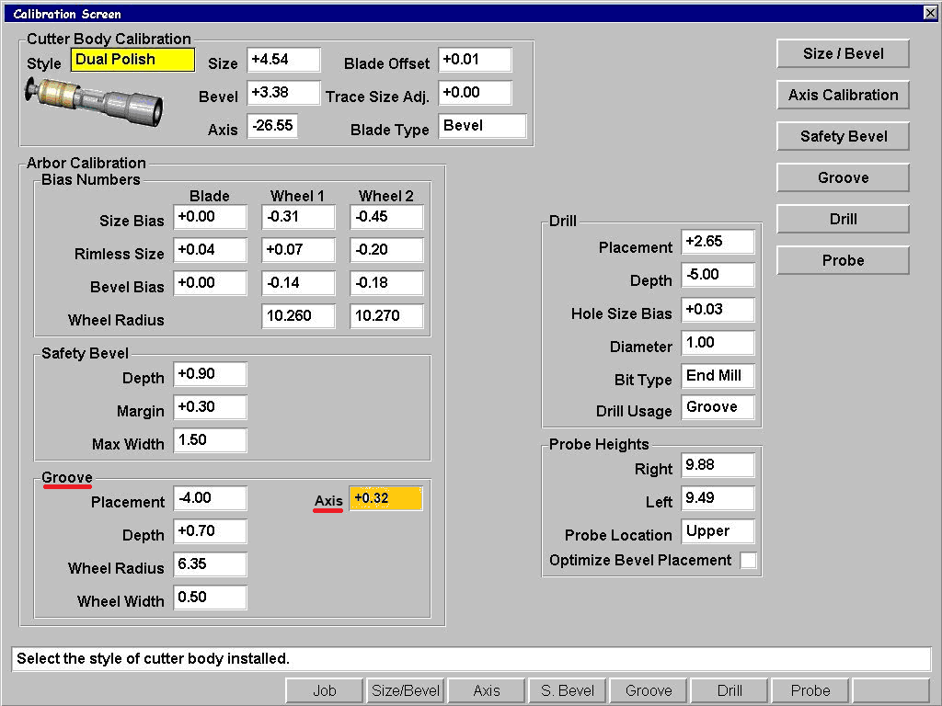

Axis: Sets the groove axis on the drill/groove combo assembly. This is a relative axis offset to the shape Axis under Arbor Calibration. Adjust this number to ensure consistent groove depth around the lens. This field only appears if Drill Usage is set to “Groove” or “Both”. Increasing this number will rotate the groove axis CCW when viewed from the front of the lens.

