Basic 7E Edger Calibration Method with Use of 4T or Dimension Tracer

NOTE: Before beginning, be sure that the “Circumference Offset” for beveled lenses is set 0.00 mm.
On the 4T, see no. 5 on the calibration menu.
On the Dimension, see the “Offsets” screen.

Step 1: Verify that tracer is calibrated on-size for tracing a beveled lens.

Using the 58 mm circular beveled lens provided with the tracer (see above), or order part no. 88502, trace it on the tracer as a beveled lens. It is extremely important to make sure you select “Beveled Lens” on the tracer screen (on the 4T, “Beveled Lens” should be highlighted at the bottom right corner of the screen). This informs the machine which object is being traced. If you trace this beveled lens as a “Rimless Lens,” “Demo,” or “Pattern” your results will NOT be accurate. The circumference of this lens is 182.21 mm.

If the c-size displayed on the tracer screen after tracing this lens is 182.2 mm, you are done verifying for the purposes of this procedure.

SEE NEXT PAGE

IF you do NOT see the above number (182.2) displayed on the tracer screen for the c-size, then proceed to the calibration screen/menu of your tracer (see example below). Using the same 58 mm circular lens described above, perform the “BEVELED LENS SIZE CALIBRATION.”
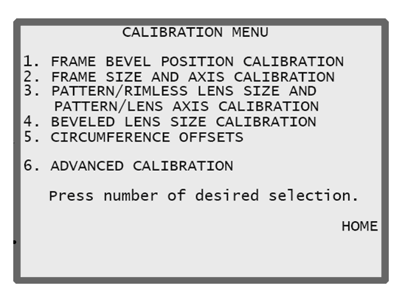

After doing the above calibration, return to the job or tracing screen, and using the 58 mm circular beveled lens provided with the tracer (see above), trace it on the tracer as a beveled lens. It is extremely important to make sure you select “Beveled Lens” on the tracer screen (on the 4T, “Beveled Lens” should be highlighted at the bottom right corner of the screen). Once again, if the c-size displayed on the tracer screen after tracing this lens is 182.2 mm (or 182.21 mm), you are done verifying for the purposes of this procedure.

Step 2: Edge a 58mm Circular Lens on the 7E

Next, proceed to the Calibration Screen and select the “Size/Bevel” key (see it at the bottom left of the screen). When you press the “Size/Bevel” key, if a password box appears in the center of the screen, ENTER the password. Then, PRESS the “Size/Bevel” key again.

A white text box will most likely appear in the center of the screen at this point, and on the keys pictured along the bottom edge of the screen there will be a “Yes” key and a “No” key.

PRESS the “No” key.

Because you are calibrating after a cutter body change or
any other time that size requires adjustment other
than after a blade change,
setup the screen as follows:
Cutter Calibration = “Body”
Box Size = “0.00”
Frame = “Metal”
Material = “Poly”
Bevel = “Center”
Polish = “􀂅” (unchecked)
Safety Bevel = “􀂅” (unchecked)

NOTE: IT IS APPROPRIATE TO USE “BLADE” IF YOU HAVE JUST REMOVED AN OLD / DULL CUTTER BLADE AND PUT A NEW ONE IN, BUT ANY ADJUSTMENTS AT THIS POINT SHOULD BE VERY SMALL (APPROX. +/- 0.10 mm Max. in Box Size).

At this point, you will need at least one spherical lens blank (having no cylinder power) with an edge thickness of about 3 – 5 mm.

Put the lens in the 7E and close the chuck.
PRESS the “Start” button on the keypad; then wait until the cycle ends.

At the end of this edging cycle, do not press any buttons on the 7E. It should stay on the “Size/Bevel” screen with the “Measured Size” highlighted until you complete Step 3.

After edging the lens, if the apex of the bevel is not off the edge of the lens, proceed to step 3.

In this figure the apex of the bevel is still on the edge of the lens in all three examples.

Step 3: Check the size of the 58mm circle lens you edged using the 4T or Dimension tracer.

Using the tracer that you verified sizing on in Step 1 of this procedure, trace the lens you edged in Step 2. Again, it is extremely important to make sure you select “Beveled Lens” on the tracer screen (on the 4T, “Beveled Lens” should be highlighted at the bottom right corner of the screen). This informs the machine which kind of object is being traced. If you trace this beveled lens as a “Rimless Lens,” “Demo,” or “Pattern” your results will NOT be accurate.

After the lens has been traced, write down the c-size displayed on the tracer screen. Take this number back to the 7E with you.

Enter the c-size value from the tracer screen into the “Measured Size” box on the edger’s “Size/Bevel” screen. Note: This Measured size box will have 58.00 in it. You will be changing it to a value of something more like 182.xx

Then, press the “OK” key at the bottom of the 7E screen.

